DBT Assignments 7 - 10
Assignment 7 - Summarizing Data with Aggregate Functions.
- Write a query that counts all orders for October 3.
- mysql> select * from orders
-> where odate = '1990-10-03';

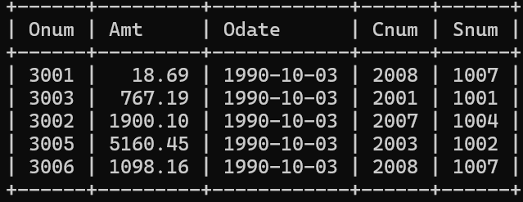

- Write a query that counts the number of different non-NULL city values in the Customers table.
- select count(distinct city) from customers
-> where city is not null;

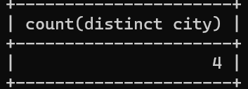

- Write a query that selects each customer’s smallest order.
- select distinct cnum , min(amt) from orders
-> group by cnum;

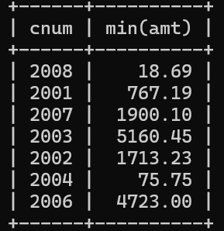

- Write a query that selects the first customer, in alphabetical order, whose name begins with G.
- select cname from customers
-> where cname like 'G%'
-> order by cname
-> limit 1;

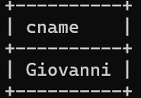

- Write a query that selects the highest rating in each city.
- select city , max(rating) from customers
->group by city;
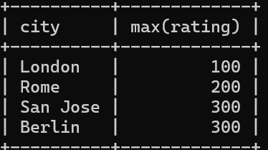

- Write a query that counts the number of salespeople registering orders for each day. (If a salesperson has more than one order on a given day, he or she should be counted only once.).
- select odate , count(distinct snum)
-> from orders
-> group by odate
-> order by odate;
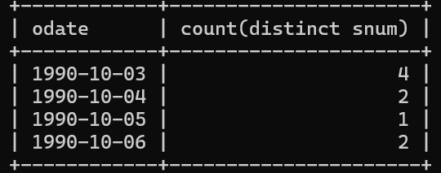

Assignment 8- Formatting Query output
- Assume each salesperson has a 12% commission. Write a query on the orders table that will produce the order number, the salesperson number, and the amount of the salesperson’s commission for that order.
- select onum , snum , amt * 0.12 as commission
-> from orders;

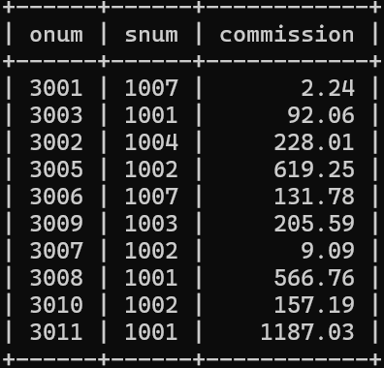

- Write a query on the Customers table that will find the highest rating in each city. Put the output in this form: For the city (city), the highest rating is : (rating).
- select city as 'For the city' , max(rating) as 'the highest rating is:' from customers
-> group by city;

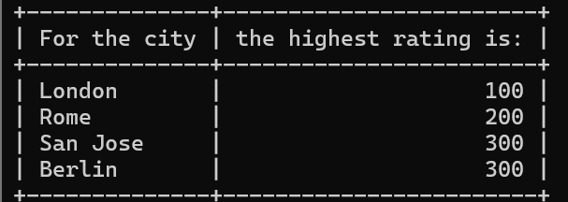

- Write a query that lists customers in descending order of rating. Output the rating field first, followed by the customer’s name and number.
- select rating, cname, cnum
-> from customers
-> order by rating desc;

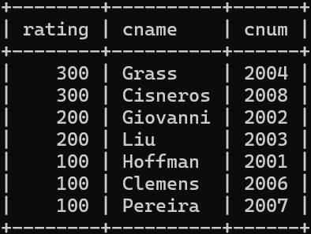

- Write a query that totals the orders for each day and places the results in descending order.
- select distinct odate ,sum(amt) from orders
-> group by odate
-> order by sum(amt) desc;
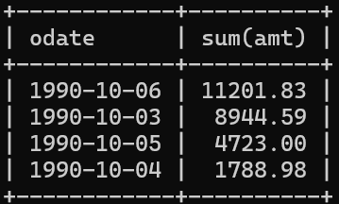

Assignment 9 - Querying Multiple Tables at Once

- Write a query that lists each order number followed by the name of the customer who made the order.
- select onum , cname from orders , customers
-> where customers.cnum = orders.cnum;

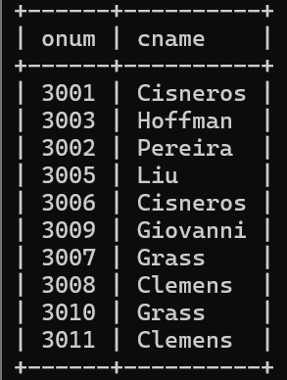

- Write a query that gives the names of both the salesperson and the customer for each order along with the order number.
- SELECT
salespeople.sname,
customers.cname,
orders.onum
FROM salespeople, customers, orders
WHERE orders.snum = salespeople.snum
AND orders.cnum = customers.cnum;
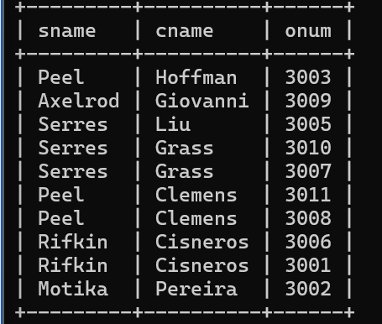

- Write a query that produces all customers serviced by salespeople with a commission above 12%. Output the customer’s name, the salesperson’s name, and the salesperson’s rate of commission.
- select customers.cname, salespeople.sname, orders.amt*0.12 from customers,salespeople,orders
-> where customers.snum = salespeople.snum and orders.cnum = customers.cnum;

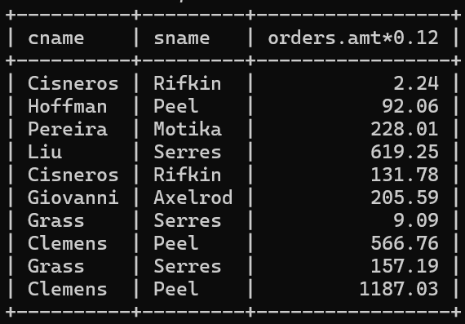

- Write a query that calculates the amount of the salesperson’s commission on each order by a customer with a rating above 100.
- select rating, amt * 0.12 from orders , customers
-> where orders.cnum = customers.cnum and rating > 100
-> order by rating;
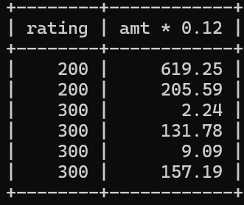

Assignment 10 - Joining a Table to Itself
- Write a query that produces all pairs of salespeople who are living in the same city. Exclude combinations of salespeople with themselves as well as duplicate rows with the order reversed.
- select s.sname , p.sname from salespeople s,salespeople p
-> where s.city = p. city and s.sname < p.sname;

- Write a query that produces the names and cities of all customers with the same rating as Hoffman.
- select cname , city from customers
-> where rating = ( select rating from customers
-> where cname = 'Hoffman');
